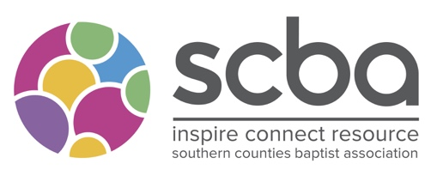
SCBA Support Grant

Please complete the form as fully as possible and send it with a heading of ‘SCBA Grant’ to office.administrator@scba.org.uk

We need a month’s notice to consider an application at a committee.

Your Name:
Church you are a member of or where you attend?

Contact details –
Email

Phone

Is this application supported by your Minister/Church Leader
Name of Minister/Church Leader
Amount Applying For?

In no more than 500 words can you tell us how this funding will support you in your trip for Christian Service?

In what ways does this link with the purposes of the SCBA?

What other funding are you receiving?

What will happen if you don’t receive funding?

Name
Signature:
Date:

